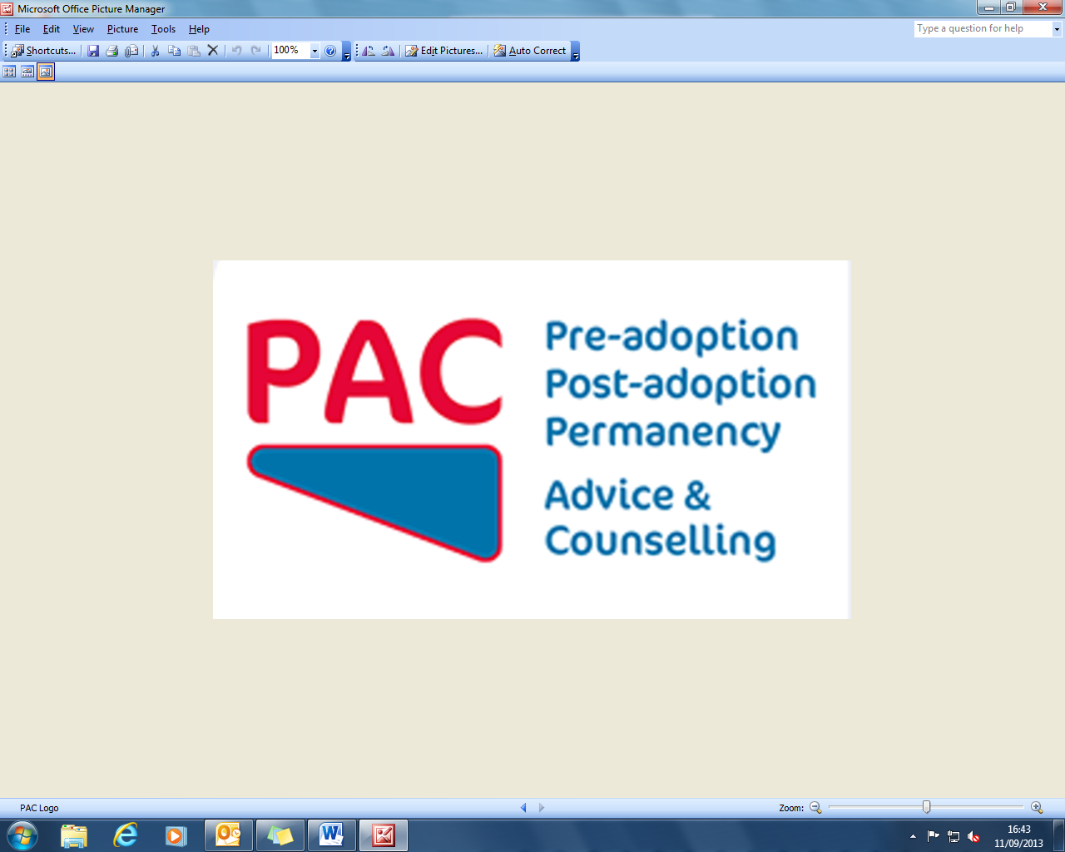

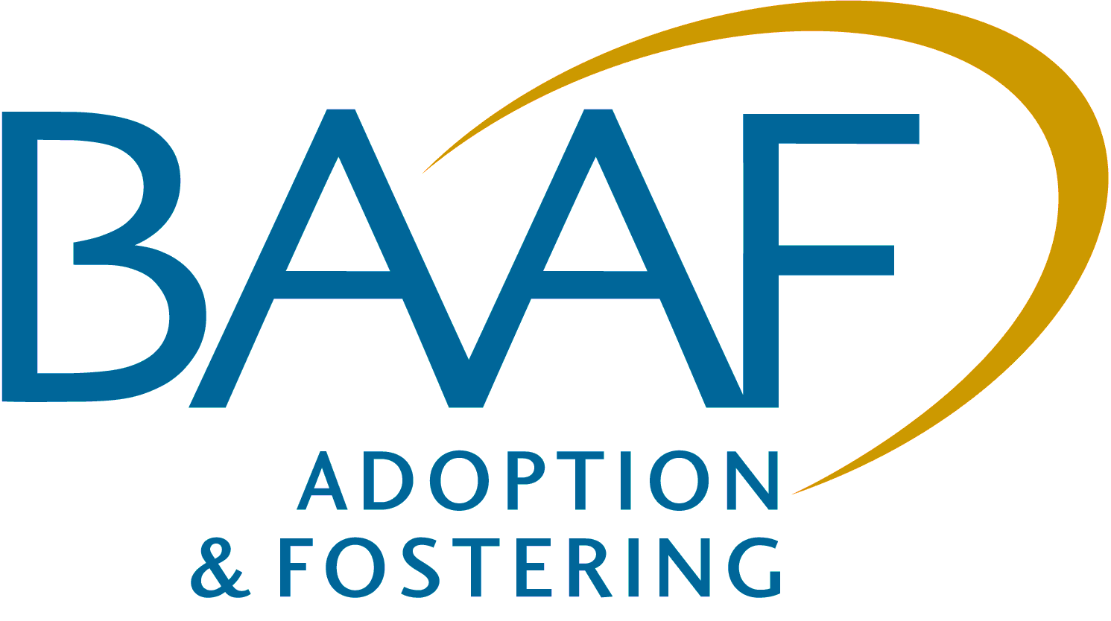

**The Prevalence, Nature and Severity of**

**Mental Health Difficulties Experienced by Looked After Children and those**

**Adopted from Care**  
  
  
A one-day workshop with Michael Tarren-Sweeney  
Associate Professor of Child & Family Psychology  
University of Canterbury, New Zealand

Thursday 17 October 2013, 10am – 4pm, BAAF, London

**THEME**

* The workshop will be conducted by Michael Tarren-Sweeney who has established an

international reputation for his studies of the development of adopted and fostered children and the risks and resilience that care populations experience in comparison to problems experienced by children in the general population. His work has particularly focused on the complexity of attachment and trauma-related difficulties. The workshop will explore the evidence base as well as the developmental concepts used to explore and explain these issues. There will be some focus during the workshop on the development of mental health screening by professionals comparing the accuracy of the SDQ when compared to his own Brief Assessment Checklist (based on the ACC measure).

**AIMS**

* To explore the nature of the developmental pathway for adopted and fostered children.
* To identify the risks and resilience factors identified through research and compare these to the general population.
* To explore how this understanding should be taken into account in planning and decision-making.
* To explore and understand the use of, advantages and disadvantages of the SDQ and the

Brief Assessment Checklist.

* To share best practice.

**WHO SHOULD ATTEND?**

The workshop is designed for Social Workers at all levels, Independent

Reviewing Officers, Panel Chairs, Advisors and Decision Makers.

**Venue:** BAAF Head Office, Saffron House, 6 -10 Kirby Street, Farringdon, London EC1N 8TS

**Timings:** Registration9.30am, Start 10.00am, Close 4.00pm Refreshments/lunch provided

**Facilitator:** Michael Tarren-Sweeney



**The Prevalence, Nature and Severity of Mental Health Difficulties Experienced by Looked After Children and those**

**Adopted From Care**

A one-day workshop

Thursday 17 October 2013  
  
  
A One-Day Workshop with Michael Tarren Sweeney

Thursday 17 October 2013 London



**REGISTRATION FORM**

|  |  |  |
| --- | --- | --- |
| Name   Name | | |
| Position | | |
| Organisation | | |
| Address/correspondence | | |
|  | | |
|  | Postcode | |
| Telephone | Fax | |
| Email: please provide for an email confirmation  Email: please provide for email confirmation and to be kept informed of future events | | |
| Requirements (e.g. dietary, disability access) | | |
| Your purchase order number | | |
| Billing address/invoice | | |
|  | | |
|  | |  |
| □ We will store your details and may want to contact you in the future with more information about our services and activities. Please tick the   box if you **do not** want us to do this. We will not pass your information on to a third party without your permission. Data Protection Act 1998. | | |

**Fees**

* £85 + vat (includes lunch and refreshments)

**Method of payment** (BAAF VAT No. 235 376458)

* Invoice
* Remittance enclosed – sterling cheque (including VAT) payable to *‘BAAF Registered Charity*‘
* Debit my MasterCard / Visa / JCB / Maestro / account with the amount of £___________________

Card number________________________________________________ Expiry date_______________ Valid from date _______________  
  
  
  
  
Issue number (Maestro only)___________________________________ 3 digit security number__________________________________  
  
  
  
Signature_________________________________________________________________ Date _______________________________

**Substiutions and cancellations:**

Substitutions are welcome at any time. BAAF reserves the right to levy the following charges in the event of cancellation:   
more than six weeks prior to the event 25% of the fee; between two and six weeks 50%; less than two weeks 100%.

Please return your completed form to

Danielle Sawyer, BAAF, Saffron House, 6-10 Kirby Street, London EC1N 8TS.

T: 020 7421 2647 F: 020 7421 2601 E: danielle.sawyer@baaf.org.uk

Registered as British Association for Adoption and Fostering. Registered Office,   
Saffron House, 6-10 Kirby Street, London EC1N 8TS. A Company Limited by Guarantee.   
Registered Number 01379092 (England and Wales) Registered Charity 275689   
(England & Wales) and SC039337 (Scotland) www.baaf.org.uk

BAAF and PAC (formerly the Post Adoption Centre)